PROFORMA OF EVENTS
- Name of the Department – Mathematics
- Event—Seminar
- Date—22.03.2022
- Title of the topic—WORLD OF MATHEMATICS AND MATHEMATICIAN
- Name and designation of the resource person—Prof. (Dr) Birendra Kumar Nayak ,Former professor and head of the department of Mathematics of Utkal University .
- Brief introduction of the Resource person- Prof. Nayak finished his post graduate degree from Banaras Hindu University. He got Ph.D degree from IIT Kharagpur,West Bengal. He worked 34 years in teaching at Vanivihar.
- Abstract of the topic—Attached herewith.
- Any other remark—The Principal, Professor Ranjit Ranjan Sahoo presided over the meeting. Prof. Jyotsnamayee Pati ,head of department introduce the resource person and elaborated on the topic. 18 faculties and 57 students of different department attend the programme. Prof.Nayak presented the topic through power point for an hour. After deliberation by resource personthe paper was opened for discussion. Prof.Nayak clarified all doubts and queries of the participants. At the end Prof Nibedita Nayak ,lecturer in Mathematics proposed vote of thanks.
- Photos of the event—Attached herewith.
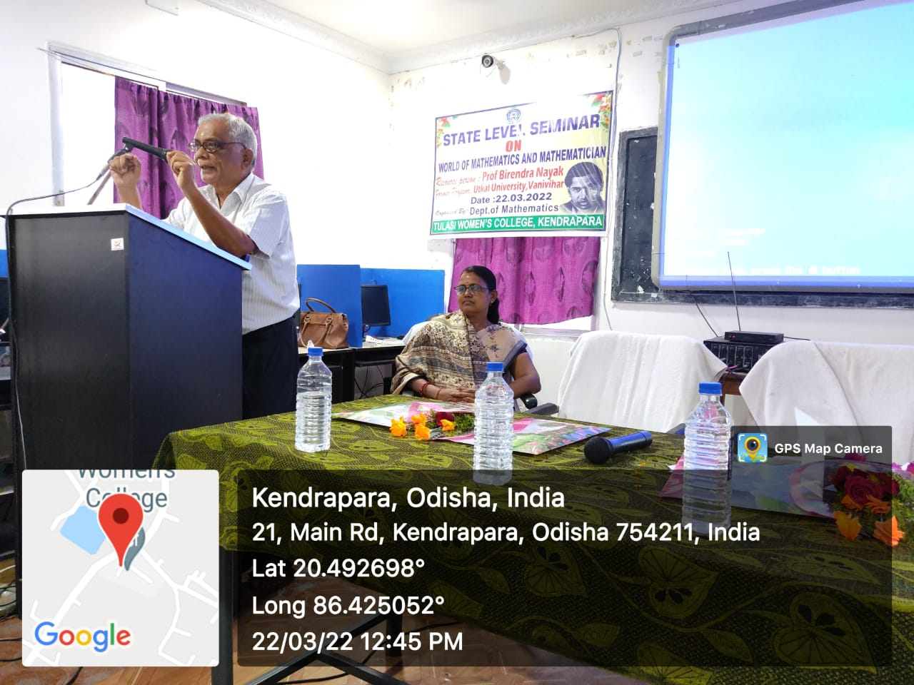
REPORT OF SEMINAR ON 22.03.2022
A seminar captioned ‘WORLD OF MATHEMATICS AND MATHEMATICIAN’ was organized by Department of Mathematics in Computer Lab on 22.03.2022 at 11AM. Professor Birendra Kumar Nayak ,Former professor and Head of the Department of Mathematics, Vanivihar graced the programme as resource person. The programme was attended by 57 students and 18 faculties. The programme was started with inaugural address by Professor Ranjit Ranjan Sahoo, Principal of the college. Prof.Jyotsnamayee Pati ,Head of the department of Mathematics,gave introductory address and spoke the objective of the programme.The resource person Professor Nayak discussed broadly on the topic through power point for one hour. An interaction session followed immediately after the deliberation of the resource person. It continued for half an hour. Prof Nayak clarified all the queries of the participants. This programme was quite engrossing and rewarding. At the end of the programme Prof. Nibedita Nayak,lecturer in Mathematics proposed vote of thanks.

