PERFORMA OF EVENTS: SEMINAR
- NAME OF THE DEPARTMENT: Department of Education
- EVENT: Seminar
- DATE: 24.02.2021 TIME-11 AM
- TITLE OF THE TOPIC: Fundamentals of Research Methodology
- NAME AND DESIGNATION OF THE RESOURCE PERSON:
Dr. Ratnamnjari Dash
Reader in Education
Kendrapara Autonomous College,Kendrapara.
Dr. Ratnamnjari Dash is presently working as a Reader in education at Kendrapara Autonomous College, Kendrapara. He has published no. of articles in National and international journals and attended no. of National and International seminars, workshops and symposiums. Besides these he has guided many students for research work.
- Abstract of the topic: Attached
- Any Other remarks:
Welcome speech and introduction of resource person was given by Miss Jayashree Behera,Lecturer in Education followed by address of resource person Dr. Ratnamanjari Dash on Fundamentals of Research Methodology.”50 students and faculty members have participated in this seminar. The programme was ended with vote of thanks by Miss Lizarani Pradhan,Lecturer in Education.

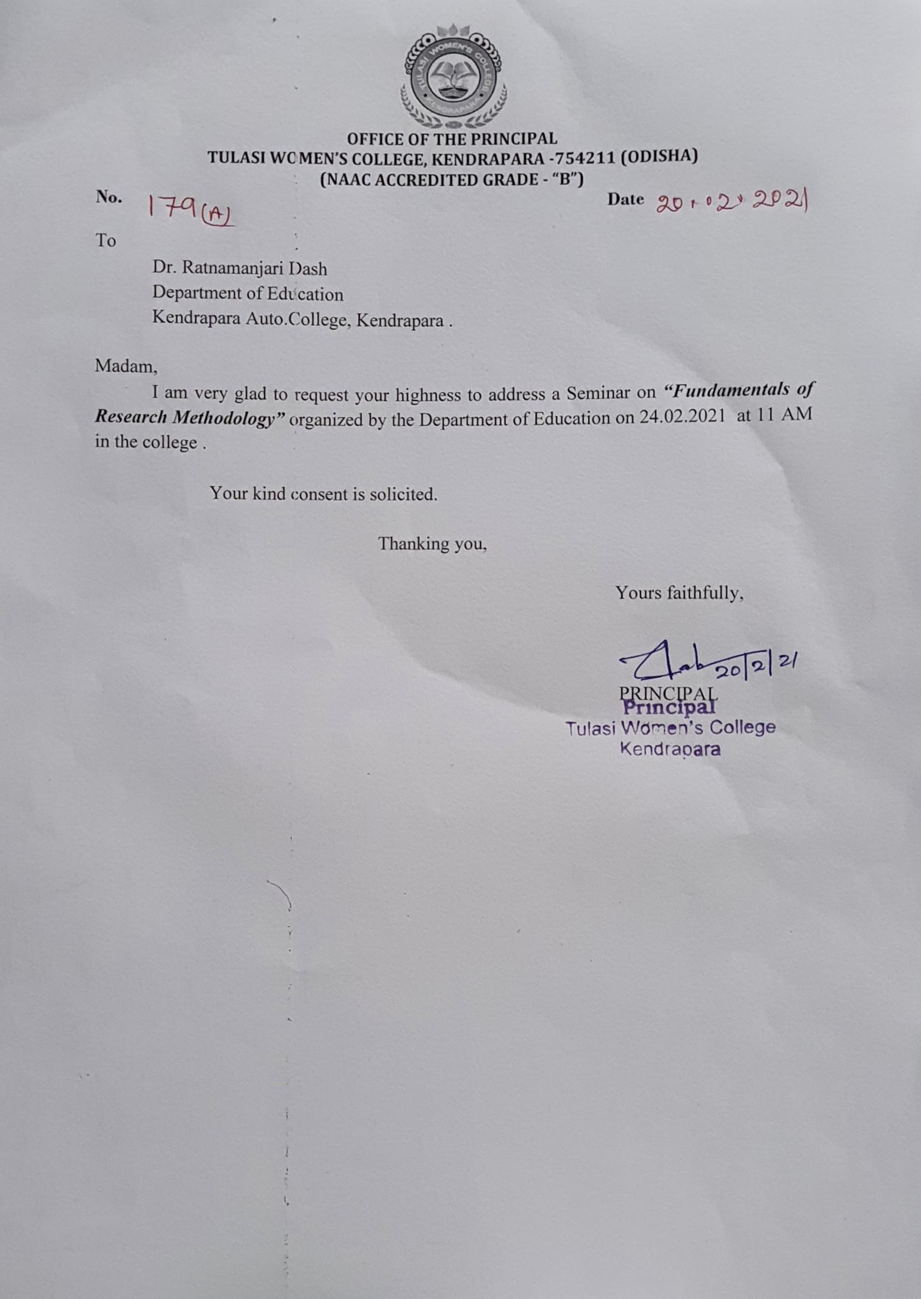
Abstract:
This paper is essential for students, scholars, Researchers, teachers and professionals in all fields of study where research is required for academic excellence. At the fundamental level, the basic knowledge and technique of carrying out research is very essential. Research scholars will investigate the major components of a research framework and be effectively exposed to them, namely problem definition, research design, data collection, ethical research concerns, report writing and submission. Once endowed with this information, participants are well situated to carry out disciplined study in the field of their choice under supervision. Besides applying to a university environment, many of the methods presented in this paper were comparable to those used in research contexts in professional research. TheFundamentals of Research methodology and Data collection aims at providing necessary steps and guidelines to researchers and postgraduates who are more often faced with the challenges of how to start and what to do at a given stage. It will help both researchers at various levels of academic endeavours as well as a guide for supervisors supervising researcher at various levels

Dr. Ratnamnjari Dash
Reader in Education
Kendrapara Autonomous College, Kendrapara

